OPTIONS AND FUTURES
Pricing, Strategy, and Risk in the World's Core Derivatives Markets
A Concise Guide from First Principles to Real-World Practice
A Level 2 module in the Quantitative Finance Curriculum
Covers: futures mechanics & margin · option payoffs · cost of carry · put-call parity · Black-Scholes & the Greeks · directional, volatility & hedging strategies · real-world case studies · the volatility surface · assignment and expiration risk

Table of Contents
How to Use This Guide
What You Need to Know Before Starting
Understand Before Proceeding
Why It Matters
How This Connects to the Rest of the Curriculum
Glossary of Recurring Terms
Part 1 — Foundations of Derivatives
1.1 Forwards, Futures, and Options at a Glance
1.2 Futures Mechanics: Margin and Mark-to-Market
1.3 Option Mechanics: Calls, Puts, and Payoffs
Part 2 — Pricing Futures and Options
2.1 Futures Pricing: Cost of Carry
2.2 Put-Call Parity and the Building Blocks of Option Value
2.3 Black-Scholes and the Greeks
Part 3 — Options and Futures Strategies
3.1 Directional and Spread Strategies
3.2 Volatility Strategies
3.3 Hedging with Futures and Options
Part 4 — Real-World Examples and Lessons
4.1 Portfolio Insurance and Black Monday (1987)
4.2 Hedging and Speculation Gone Wrong: Barings and Metallgesellschaft
4.3 Negative Oil (2020) and Volmageddon (2018)
Part 5 — Risk Management and Practical Considerations
5.1 Margin, Leverage, and Clearing
5.2 The Volatility Surface and Skew
5.3 Pitfalls: Assignment, Pin Risk, and Expiration
Practical Exercise
Common Beginner Mistakes
Advanced Extensions
Professional Applications
Where to Go Next

How to Use This Guide
This guide introduces options and futures, the two families of exchange-traded derivatives that sit beneath most of modern risk management, speculation, and hedging. It moves from basic mechanics to pricing theory, trading strategy, real-world case studies, and risk management — each section pairing a short explanation with a formula, a figure, or a worked example. This module favors brevity over exhaustive detail: read it start to finish for a complete but compact picture, or jump to any part using the Table of Contents.

What You Need to Know Before Starting
- Basic statistics — mean, standard deviation, and the normal distribution, used throughout option pricing.
- Present value and interest rates — simple discounting underlies futures and forward pricing.
- Portfolio basics — long and short positions, and the idea of a hedge.

Understand Before Proceeding
Prerequisite gate — A derivative's price is derived from an underlying asset, but the two do not always move in lockstep, and leverage means a small move in the underlying can produce a large gain or loss in the derivative. Every pricing formula in this guide describes a theoretical fair value under stated assumptions, not a guarantee. The real-world cases in Part 4 exist specifically to show what happens when leverage, liquidity, or those assumptions break down.

Why It Matters
Options and futures let a company lock in a price months in advance, let an investor insure a portfolio against a crash, and let a speculator take a large position with a small amount of capital — the same leverage that makes them useful also makes them dangerous when misunderstood. Several of history's largest single-firm financial losses trace directly back to derivatives positions that were misunderstood, mis-hedged, or simply too large — which is exactly why this guide pairs every pricing concept with a real-world consequence.

How This Connects to the Rest of the Curriculum
- Factor Models & Statistical Arbitrage — Futures and options are the standard tools used to hedge the factor exposures and pair positions covered in those modules.
- FX — FX forwards and options, covered there in currency terms, follow the identical pricing logic developed here in Part 2.
- Crypto — The perpetual future is a crypto-specific variant of the futures contract covered in Part 1.2.

Glossary of Recurring Terms
Derivative — A financial contract whose value is derived from an underlying asset, rate, or index.
Futures contract — A standardized, exchange-traded agreement to buy or sell an asset at a set price on a future date.
Option — A contract giving the right, but not the obligation, to buy (call) or sell (put) an asset at a set strike price.
Strike price — The fixed price at which an option's holder may buy (call) or sell (put) the underlying asset.
Premium — The price paid by an option buyer to its seller (writer) for the rights the option confers.
Margin — Collateral posted to a broker or clearinghouse to cover potential losses on a leveraged futures or options position.
Mark-to-market — The daily process of settling gains and losses on a futures position against the day's closing price.
Intrinsic value — The immediate exercise value of an option — how far in-the-money it is, if at all.
Time value — The portion of an option's premium above its intrinsic value, reflecting the chance the option becomes more valuable before expiration.
Implied volatility — The volatility level that, put into an option pricing model, reproduces the option's observed market price.
The Greeks — A set of sensitivities (delta, gamma, theta, vega, rho) describing how an option's price responds to changes in the underlying, time, and volatility.
Put-call parity — A no-arbitrage relationship linking the prices of a call and put with the same strike and expiration to the underlying and a risk-free bond.
Contango / backwardation — The condition of a futures curve sloping upward (contango) or downward (backwardation) as maturity lengthens.
Clearinghouse — A central counterparty that stands between buyer and seller on every exchange-traded futures or options contract, guaranteeing performance.
Assignment — The process by which an option seller is required to fulfill the contract after the buyer exercises it.

Part 1 — Foundations of Derivatives
Part 1 covers the basic mechanics of futures and options: what each contract promises, how it settles, and how its payoff looks at expiration.

1.1 Forwards, Futures, and Options at a Glance
A forward is a private agreement between two parties to trade an asset at a set price on a future date. A futures contract is the same idea, standardized and traded on an exchange, with a clearinghouse guaranteeing both sides. An option is different in kind: it grants a right, not an obligation — the buyer can walk away and lose only the premium paid, while the seller must perform if asked.
Feature | Forward | Futures | Option
Obligation to trade? | Yes, both sides | Yes, both sides | Buyer: no. Seller: yes, if exercised
Standardized / exchange-traded? | No (OTC) | Yes | Usually yes
Upfront cost | None | Margin only | Premium paid by buyer
Max loss for the buyer | Unlimited (in theory) | Unlimited (in theory) | Premium paid

1.2 Futures Mechanics: Margin and Mark-to-Market
A futures buyer does not pay the full contract value upfront. Instead, both sides post margin — a small good-faith deposit — and gains or losses are settled in cash every day through mark-to-market: the exchange compares today's settlement price to yesterday's and moves cash accordingly. This is what makes futures highly leveraged: a small margin deposit controls a much larger notional exposure.
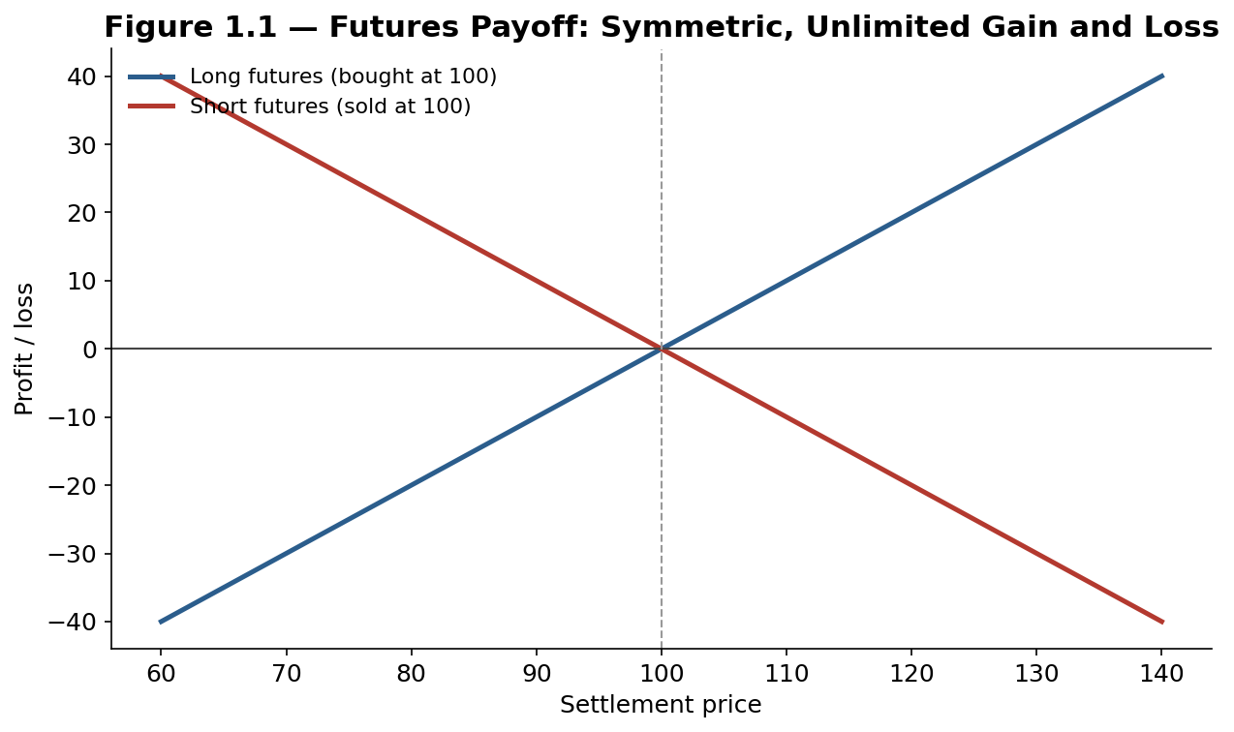
Figure 1.1 — A futures payoff is linear and symmetric: the long side gains dollar-for-dollar as price rises, the short side gains dollar-for-dollar as it falls, with no cap on either side.
Worked example — A trader buys one crude oil futures contract (1,000 barrels) at $75, posting $5,000 margin. If the price rises to $77, the daily mark-to-market credits the account $2,000 — a 40% return on margin from a 2.7% move in the underlying. The same leverage applies, in reverse, to a loss.

1.3 Option Mechanics: Calls, Puts, and Payoffs
A call gives the right to buy at the strike price; a put gives the right to sell. A buyer's loss is capped at the premium paid, while the upside is open-ended for a call and large (down to zero) for a put — the defining asymmetry that separates options from futures.
Call payoff = max(S − K, 0) Put payoff = max(K − S, 0)
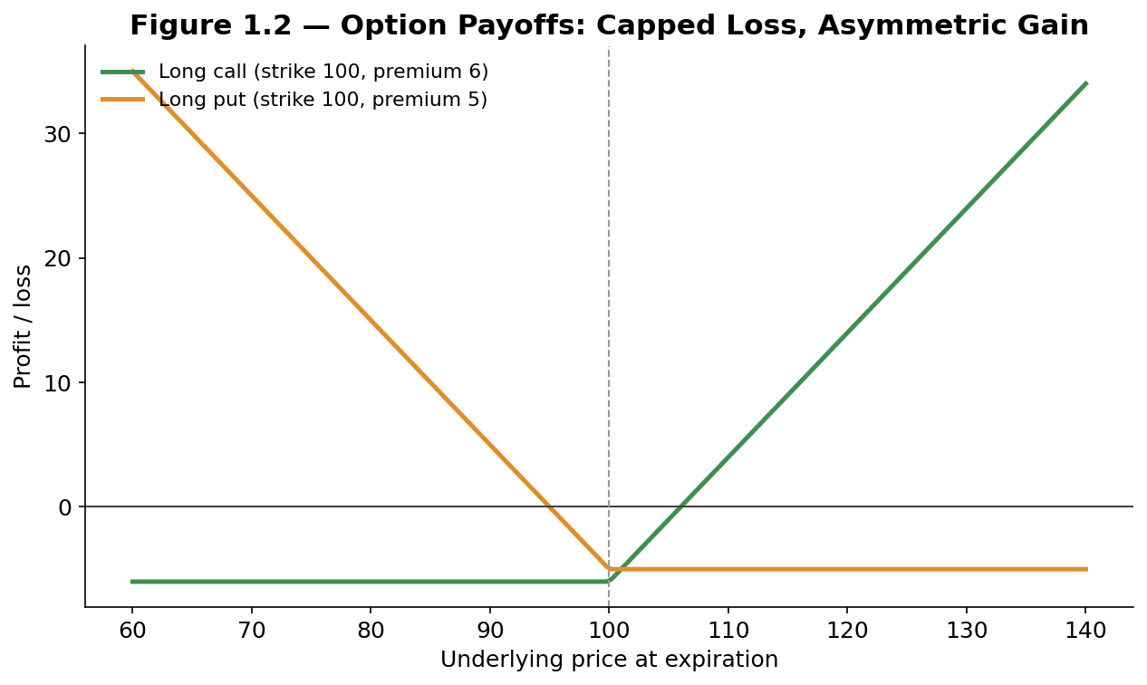
Figure 1.2 — Long options cap the downside at the premium paid while leaving the upside open — the mirror image of a futures position's symmetric, unlimited payoff.

Part 2 — Pricing Futures and Options
Part 2 covers the no-arbitrage logic that prices a futures contract relative to spot, and the framework — culminating in Black-Scholes — used to price options.

2.1 Futures Pricing: Cost of Carry
A futures price is anchored to the spot price by the cost of carry: the cost of financing and storing the underlying asset until delivery, net of any yield it pays.
F = S × e^((r + storage − yield) × T)
When carry costs exceed yield, the futures curve slopes upward (contango); when yield exceeds carry cost — common for commodities in tight supply — the curve slopes downward (backwardation).
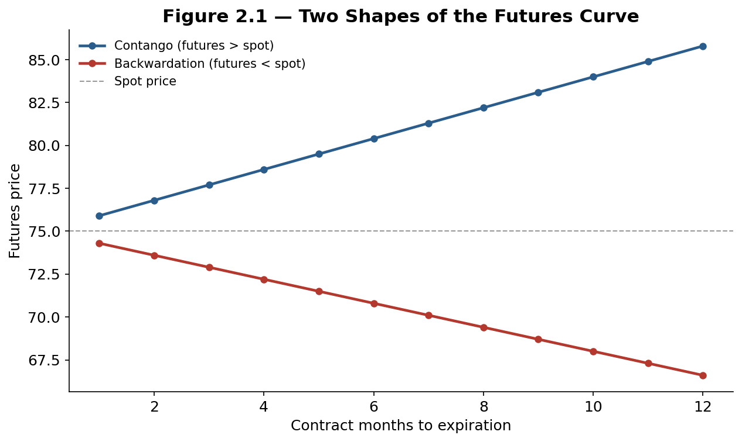
Figure 2.1 — Contango and backwardation are mirror images of the same cost-of-carry relationship, and a single commodity can flip between the two as supply and demand conditions change.

2.2 Put-Call Parity and the Building Blocks of Option Value
Put-call parity links a call and put of the same strike and expiration to the underlying and a risk-free bond — a pure no-arbitrage relationship, independent of any model:
C − P = S − K × e^(−rT)
Separately, every option's premium splits into two parts: intrinsic value (what it would be worth if exercised right now) and time value (the extra amount reflecting the chance it becomes more valuable before expiration, which decays to zero at expiration).
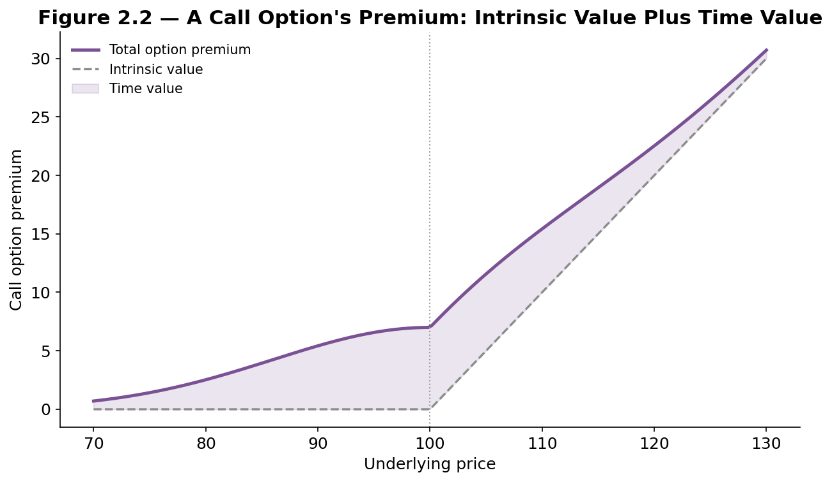
Figure 2.2 — Time value is greatest near the strike, where the outcome is least certain, and shrinks to zero deep in- or out-of-the-money and as expiration approaches.

2.3 Black-Scholes and the Greeks
The Black-Scholes model prices a European option from five inputs — spot price, strike, time to expiration, volatility, and the risk-free rate — under assumptions of constant volatility and no jumps.
C = S·N(d1) − K·e^(−rT)·N(d2)
The Greeks describe how that price moves as each input changes: delta (sensitivity to the underlying), gamma (rate of change of delta), theta (time decay), vega (sensitivity to volatility), and rho (sensitivity to interest rates). Traders manage a book of options primarily by managing its Greeks, not by re-running the pricing model on every trade.
Tip — Delta doubles as an approximate probability of expiring in-the-money and as the hedge ratio: a 0.40-delta call behaves, for small moves, like holding 40 shares of the underlying per contract — the basis for delta-hedging a book of options.

Part 3 — Options and Futures Strategies
Part 3 surveys the standard building blocks traders combine into directional bets, volatility bets, and hedges.

3.1 Directional and Spread Strategies
A long call or put is the simplest directional bet. Spreads combine two options to trade off upside for a lower cost and narrower risk: a bull call spread buys a lower-strike call and sells a higher-strike call, capping both cost and payoff; a bear put spread does the mirror image to the downside.
Worked example — With the stock at 100, a trader buys the 100-strike call for 6 and sells the 110-strike call for 2 — a net cost of 4, with a maximum payoff of 10 if the stock finishes at or above 110. The trade caps profit at 6 (150% return) in exchange for a lower cost than the outright call.

3.2 Volatility Strategies
A long straddle (buy a call and put at the same strike) profits from a large move in either direction and loses only if the underlying stays near the strike. An iron condor sells a straddle-like structure further out-of-the-money instead, profiting if the underlying stays within a range — the mirror-image bet.
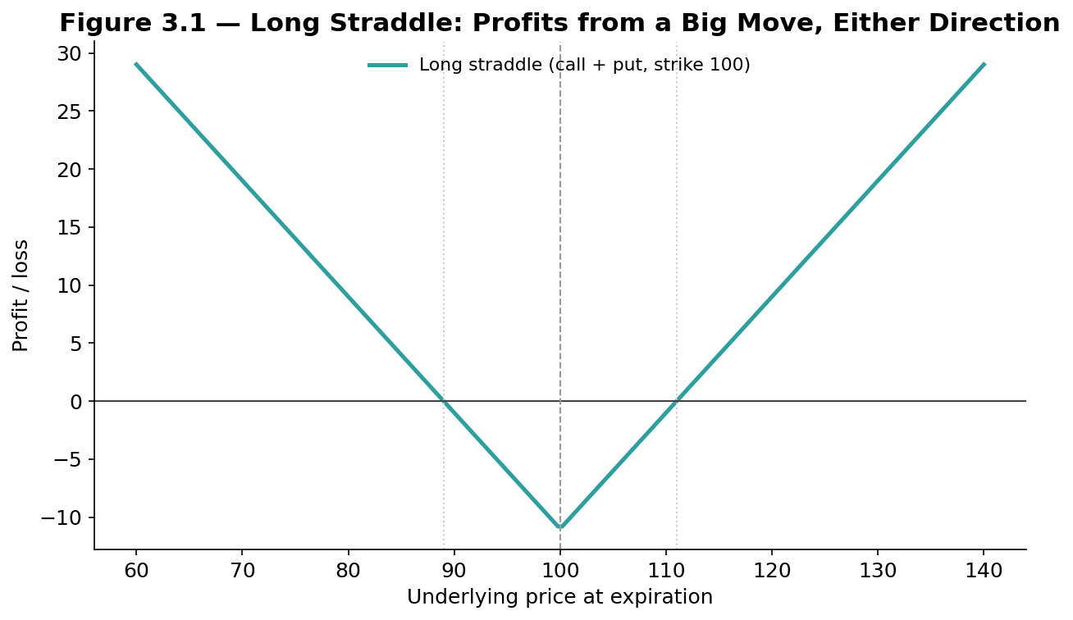
Figure 3.1 — A long straddle's V-shaped payoff profits from movement itself, in either direction, and loses only if the underlying sits still through expiration.

3.3 Hedging with Futures and Options
A wheat farmer can sell wheat futures today to lock in a future sale price, eliminating the risk of a price decline before harvest. A portfolio manager can buy index puts as portfolio insurance, capping downside for the cost of the premium — or sell covered calls against a long stock position to generate income in exchange for capping the upside.
Tip — A hedge is not free: locking in a price or capping downside also gives up the corresponding upside. Judge a hedge by whether it reduced the variability of outcomes as intended, not by whether it "made money" in hindsight.

Part 4 — Real-World Examples and Lessons
Part 4 pairs four of the best-documented derivatives episodes in financial history with the specific mechanism, covered in Parts 1–3, that each one illustrates.

4.1 Portfolio Insurance and Black Monday (1987)
Ahead of October 1987, many institutional funds ran portfolio insurance: a strategy that used S&P 500 futures to mechanically sell more futures as the market fell, aiming to replicate a protective put synthetically. On 19 October 1987, this created a self-reinforcing loop — falling prices triggered more futures selling, which pushed prices down further — and the Dow fell 22.6% in a single day, still the largest one-day percentage decline in its history. The episode remains the canonical warning that a hedge built from dynamic trading, rather than an actual option position, can fail exactly when it is needed most, if enough participants run the same strategy at once.

4.2 Hedging and Speculation Gone Wrong: Barings and Metallgesellschaft
Barings Bank (1995) collapsed after trader Nick Leeson accumulated enormous unauthorized directional positions in Nikkei 225 futures, disguising mounting losses in a hidden account; a single trader's leveraged futures book bankrupted a 233-year-old bank. Metallgesellschaft (1993) shows the opposite failure mode: the German firm's US subsidiary ran a legitimate hedging program using short-dated oil futures to hedge long-term fixed-price fuel contracts, but a sharp fall in oil prices triggered huge margin calls on the futures hedge — a real cash-flow crisis — even though the hedge was economically sound over the long term. Together, the two cases separate two distinct risks: unauthorized speculation, and the liquidity risk a correct hedge can still create.

4.3 Negative Oil (2020) and Volmageddon (2018)
On 20 April 2020, the expiring WTI crude oil futures contract settled at −$37.63 a barrel — traders holding long positions into expiration faced physical delivery with no available storage, amid a pandemic-driven demand collapse, and paid others to take the oil off their hands. It was the first negative settlement in the contract's history and a stark lesson in the mechanics of physical delivery.
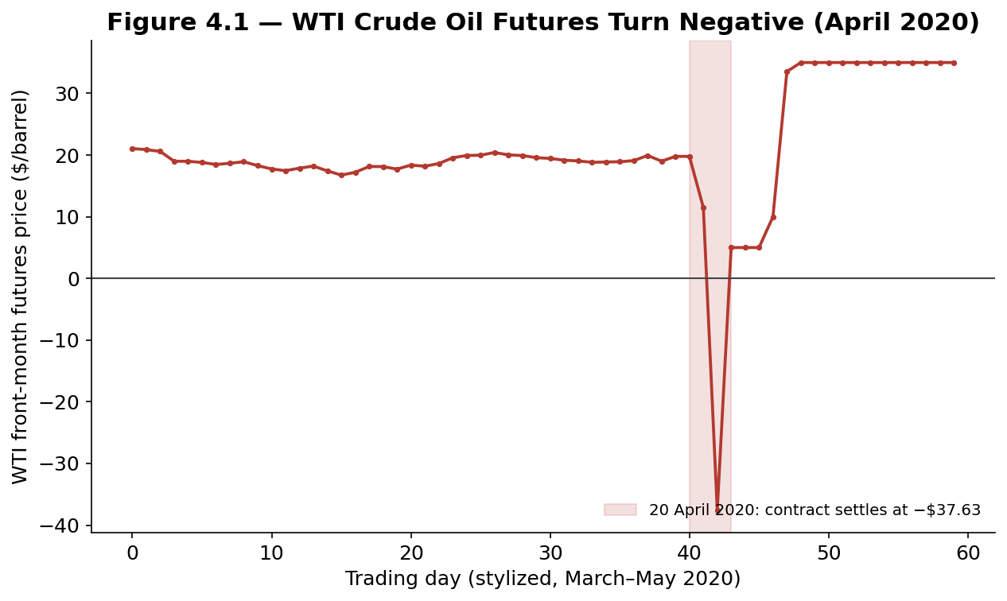
Figure 4.1 — With storage exhausted and delivery obligations looming, holders of the expiring contract briefly paid buyers to take crude oil off their hands.
In February 2018, popular exchange-traded products that were short volatility (effectively short VIX futures, profiting as long as markets stayed calm) were caught by a sudden spike in the VIX; several were forced to buy huge quantities of VIX futures to cover their short exposure, amplifying the very spike they were reacting to. The event, nicknamed "Volmageddon," wiped out one popular product (XIV) almost entirely in a single session.
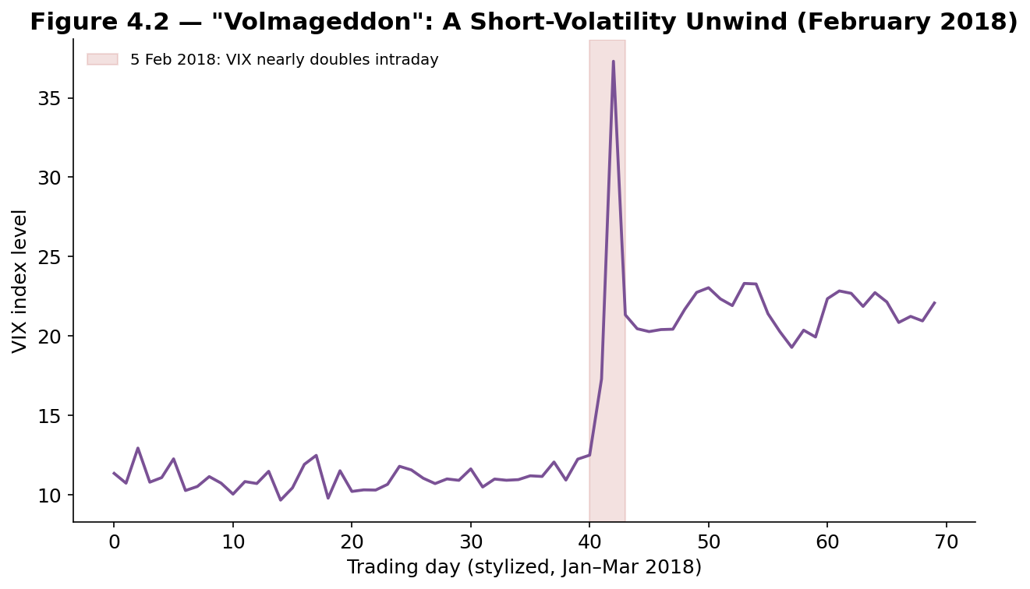
Figure 4.2 — A crowded short-volatility trade unwound in hours: the forced buying needed to cover short VIX futures positions itself drove the VIX sharply higher, a feedback loop conceptually similar to 1987's portfolio-insurance cascade.

Part 5 — Risk Management and Practical Considerations
Part 5 closes with the practical mechanics of trading derivatives safely: how margin and clearing actually work, how implied volatility varies across strikes, and the operational pitfalls that most often catch newcomers off guard.

5.1 Margin, Leverage, and Clearing
A clearinghouse sits between every buyer and seller on an exchange, guaranteeing performance and eliminating direct counterparty risk — the buyer need not worry about the seller's creditworthiness, only the clearinghouse's. This guarantee is funded by initial margin (posted at trade entry) and variation margin (the daily mark-to-market settlement from Part 1.2); a trader who cannot meet a margin call has the position force-liquidated.
Common mistake — Sizing a futures or options position by the premium or margin required rather than by the full notional exposure it controls. Leverage magnifies both directions equally, and the margin required to open a position is not a measure of the maximum loss it can produce.

5.2 The Volatility Surface and Skew
Black-Scholes assumes one constant volatility, but real markets price different strikes at different implied volatilities — a pattern called the volatility skew or smile. In equity index options, this typically takes the form of a smirk: out-of-the-money puts trade at persistently higher implied volatility than out-of-the-money calls, reflecting the market's pricing of crash risk more heavily than an equivalent rally.
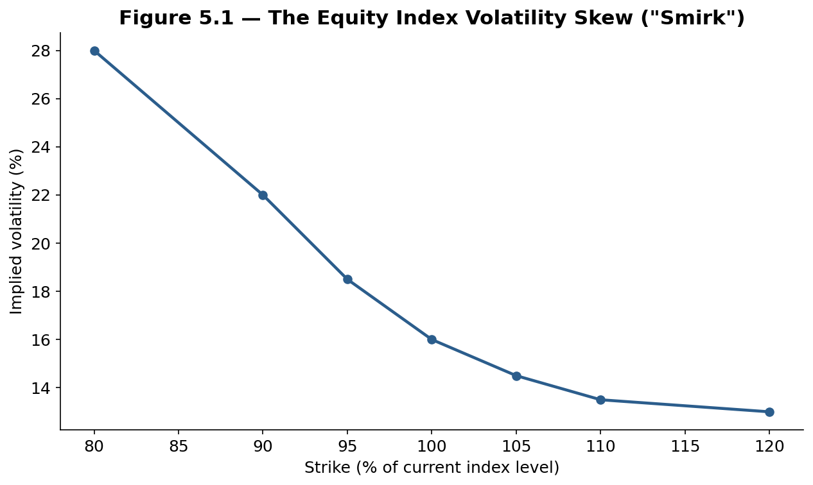
Figure 5.1 — The equity index volatility skew: downside strikes are structurally more expensive than upside strikes, a pattern that became far more pronounced across the market after the 1987 crash.

5.3 Pitfalls: Assignment, Pin Risk, and Expiration
An option seller can be assigned — required to deliver or buy the underlying — at any time for an American-style option, sometimes unexpectedly around dividend dates. Pin risk arises when the underlying settles very close to the strike at expiration, leaving the option holder uncertain whether it will be exercised and exposed to an unintended position on the next trading day. Both risks are administrative rather than analytical, and are easy to overlook until they cause an unwanted, unhedged position.
Tip — Close or roll a position well before expiration if an unintended assignment would be a problem, rather than assuming a deep out-of-the-money short option is guaranteed to expire worthless — a sharp last-day move can change that outcome with no time left to react.

Practical Exercise
Pick a liquid, exchange-traded stock or index. Pull its current option chain and identify the at-the-money implied volatility, then compare it to a 25-delta put and 25-delta call to measure the skew directly. Separately, price a bull call spread and a long straddle using the chain's actual quoted prices, and sketch each payoff diagram by hand before checking it against Part 3.
# Skeleton for the practical exercise

def bs_call(S, K, T, r, sigma):
d1 = (np.log(S/K) + (r + 0.5*sigma**2)*T) / (sigma*np.sqrt(T))
d2 = d1 - sigma*np.sqrt(T)
return S*norm.cdf(d1) - K*np.exp(-r*T)*norm.cdf(d2)

def straddle_payoff(S_range, K, premium_total):
return np.maximum(S_range-K,0) + np.maximum(K-S_range,0) - premium_total

# Evaluate: skew shape, spread max profit/loss, and where the
# straddle's break-even points sit relative to current implied vol.

Common Beginner Mistakes
- Buying options without a view on volatility, not just direction — a correct directional call can still lose money if implied volatility falls enough.
- Ignoring time decay — an out-of-the-money option can lose value daily even if the underlying is flat.
- Treating margin as the maximum possible loss — leverage means losses can exceed the initial margin posted.
- Running a dynamic hedge and assuming it behaves like the real option — as Black Monday illustrated.
- Holding short options into expiration without a plan — risking pin risk or unwanted assignment.

Advanced Extensions
- Stochastic and local volatility models — extending Black-Scholes to price the skew directly.
- Exotic options — barriers, Asians, and other path-dependent payoffs beyond standard calls and puts.
- Volatility derivatives — trading VIX futures and options directly on volatility itself.

Professional Applications
- Market makers — quote two-sided option prices and manage risk through the Greeks in real time.
- Corporate treasuries — hedge commodity, currency, and interest-rate exposure with futures and options.
- Volatility and derivatives desks — trade the strategies in Part 3 systematically, at scale.

Where to Go Next
This guide covered derivatives mechanics, pricing, strategy, real-world lessons, and risk management. The FX module extends the same pricing logic to currency forwards and options; the Statistical Arbitrage module covers the basis trade this guide's cost-of-carry framework underlies; and the Risk Metrics module builds on Part 5 to cover portfolio-level derivatives risk in full depth.

